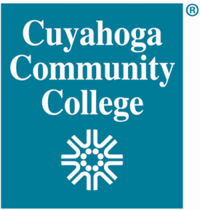
Cuyahoga Community College

FBI Cleveland Citizens Academy Alumni Association 2023 Financial Aid Program

Your information here to provide financial aid to students in Tri-C’s Police Academy.

SCHOLARSHIP REQUIREMENTS:

- Accepted into the Basic Police Academy
- Meets all Basic Police Academy application requirements
- Must be a U.S. Citizen
- Must have completed a financial aid application (follow links on Tri-C website)
- Must demonstrate financial need

APPLICATION PROCESS:

In addition to completing this form, to be considered for the scholarship students must:

- Write and submit a short essay (up to 200 words, typed, double-spaced) explaining how the scholarship will assist in your educational endeavors. Must be typed and double spaced. Both this form and the essay must be e-mailed to kiksharley@aol.com by no later than March 30, 2023.

- Complete online at www.fafsa.gov the Free Application for Federal Student Aid (FASFA) or use the link on the Tri-C website. You do not need to be FAFSA eligible to qualify.

NOTE: Selected candidates will be awarded $500.00 which will be paid upon graduation from the Police Academy. Consideration is based on financial aid received by the student and the student’s other financial needs. Must graduate from the class to be eligible for the $500 scholarship.

PLEASE PRINT:

Name: _____________________________________________Student ID# _______________________________

Home Address: _______________________________________________________________________________

City: _________________________________State:_______________ Zip: ___________County: _______________

Cell Phone # ________________________ E-Mail Address:____________________________________________-

I certify that the information provided is accurate. The FBICLECAAA may use the information I have provided to support its mission. If a recipient is found to have an undisclosed criminal conviction, they will not be eligible to receive the scholarship.

Signature:

